Paper template for contribution in conference STC
Jiří Moravec^{1,*}, Second Author²
¹ CTU in Prague, Faculty of Mechanical Engineering, Department of Process Engineering, Technická 4, 166 07 Prague 6, Czech Republic
² A supervisor can be as the other author (not obligatory)
Abstract
This document serves as a template for preparation of a full text of a contribution in the conference STC. At the beginning, the paper content should be described briefly in a single paragraph with few rows (max. 10). The abstract body should be typed in normal, 9 pt, Times font. It should be written with single line spacing and justified. The text is introduced by the heading “Abstract” written in a separate row. The heading is typed in Arial, bold, 10 pt, and left aligned. An empty space 8 mm should be left above the heading. Within the space, a horizontal continuous line of width 0.25 mm and length 17 cm is placed 2 mm above the heading. The space between the heading and the text of the abstract is 2 mm. Under the abstract, keywords describing the content should be listed. The keywords are separated from the abstract by an empty space 3 mm and introduced by the text “Keywords: ” typed in Times, italics, 9 pt. The keywords should be typed in the same font like the abstract and separated by semicolons. After the keywords, an empty space 10 mm should be left. Within the space, the same line as the line above the abstract is placed 2 mm below the keywords. The whole text between the lines (abstract and keywords) should be intended 1 mm from the left and right page margins.
Keywords: STC; contribution; template; information; formatting
1. Page layout and text formatting
The A4 paper format should be used for writing the full text. The page margins should be set to 2 cm except the top margin which is 2.5 cm. Use a two-column format with the space between the columns set to 8 mm. The title, authors, affiliations, abstract, and keywords are typed in one-column format.
The header margin is set to 1.2 cm, the footer to 1.4 cm. Headers in all pages (except the first one) should contain the following text “Student’s conference 2020 | Czech Technical University in Prague | Faculty of Mechanical Engineering” centred. In the footer of the first page, the text “Corresponding author: ” followed by an email address of the first author should be inserted (everything set in Times, 9 pt, left aligned with a line of thickness 0.25 mm and length 5 cm placed 1 mm above the text). Do not add any page numbers.
1.1. Formatting the title, authors and affiliation
1.1.1. Formatting the title
The title should be typed in Arial, bold, size 14 pt and centred (not justified). The first letter should be capitalised, the rest in lower case (with exception of abbreviations, words written capitalised, etc.). Free space 10 mm before the title and 6 mm after the title should be left. The title is intended 8 mm from the left and right margins.
1.1.2. Formatting author names and affiliations
Author names should be set in Arial, 10 pt, and centred. Write the names without titles in the format Name Surname. The article may have one or more authors. The first author should be the author who created the marginal part on the work. In the case of the conference, it is assumed that the marginal part of the work is done by a student, who will be thus the first and the presenting author at the same time. Naming authors and their order is fully in competency of the author(s). Supervisor can be also among co-authors.
The author’s affiliations should be typed in Arial, italics, 8 pt, and centred. If there are more authors from different affiliations, a system of footnotes can be used for specification of correct affiliation to each author. In the case, the affiliations should be preceded by a numerical superscript corresponding to the same superscript written after the name of the author concerned. This system is not necessary to use if all of the authors have the same affiliation. The affiliation should be as complete as possible including the country.
An empty space 4 mm should be left between the authors’ names and affiliations. Both groups of texts are intended 8 mm from the left and right margin as in the case of paper title.
1.2. Formatting the text
The text of the paper should be written in Times, 10 pt, with single line spacing and should be justified. The first paragraph after a heading is not intended. The subsequent paragraphs should be intended by 5 mm.
Division of the text into sections, subsections and subsubsections is optional according to the author’s needs. The three levels of the text groups should not be exceeded. All headings should be numbered. To format sections, subsections and subsubsections, information in the table 1 should be followed.
Table 1. Information about headings formatting.
Level | Font | Spacing | Numbering
Section | Arial, bold  size 12 pt | 6 mm before  3 mm after | 1., 2., …
Subsection | Arial, bold  size 10 pt | 6 mm before  3 mm after | 1.1., 1.2., …
Subsubsection | Arial, italics  size 10 pt | 6 mm before  3 mm after | 1.1.1., 1.1.2., …
The minimum range of paper number of pages is limited by 2, maximum is 12 pages. The text should be written in odd number of pages. In the case that the text on the last page does not reach down to one fourth of the right column at least, the text in the left column should be broken so it fills both columns equally.
The whole text (including title and abstract) should be written in the same language in which the paper presentations is planned to be kept. The choice of the language is done during registration of the contribution (see information on the conference website [1]). Undergraduate students can choose from Czech, Slovak or English language, postgraduate students can choose from any of the foreign languages listed in the list in registration system.
2. Tables and figures
Tables and figures should be sufficiently well-arranged with clearly readable letters in all captions. In tables, it is recommended to use 9-point Times font or 8-point Arial font. Even figures and graphs should be arranged in the way so the size of letters corresponds approximately to the mentioned recommendations.
Tables and figures can be arranged in both designs, the colour or the shades of grey (author’s choice). In figures attention should be paid to use well-contrasted lines and elements. Even though contributions will be a part of a proceedings in electronic form, it is good to think on the possibility of printing the pages which can cause losses of information value of elements in the case of monochrome printing. Thus it is good to distinguish lines in graphs not only by colours but also by type of each line, for example (see Fig. 1). Try to ensure that lines in figures are no thinner than 0.1 mm (0.3 point). Distance between figures or tables and surrounding text should be 3 mm.
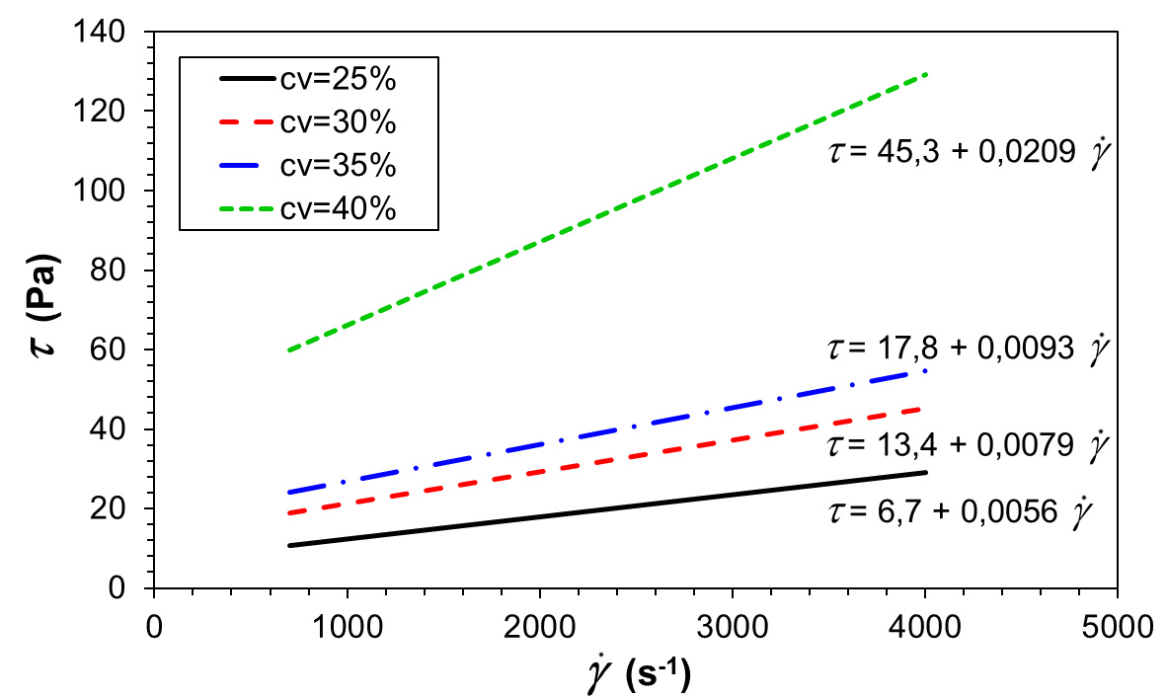
Figure 1. Caption of the figure 1 – flush left below the figure.
2.1. Figures and tables captions
Figure or table captions should be typed in Times, italics, 9 pt, and flush left. Table captions should be introduced by the text “Table ” followed by the serial number of the table and a dot (typed in bold). The text of the table caption follows after the dot (and space) with a capital first letter. The caption should be placed before the table.
Figure captions should be introduced by the word “Figure ” followed by the serial number of the figure and a dot (everything in bold). After a space there follows the own text of the caption (again with the first letter capitalised). Figure captions should be placed after the figures.
Both, tables and figures, should be numbered continuously throughout the text, independently on dividing the text into sections. Captions should be intended from the surrounding text by 3 mm.
2.2. Positioning figures and tables
Figure or table should be placed as close as possible to the point where it is firstly referenced in the text. If there is higher number of figures or tables it might be necessary to place some of them before their citation in the text. If a figure or table is too large to fit in one column, it can be centred across both columns at the top or the bottom of the page.
3. Equations and mathematics
Equations should be written in separate rows, centred and numbered continuously throughout the text with the number placed in brackets on the right side of the column (on the same row as the equation).
$ρ\left(\frac{∂\vec{u}}{∂t}+\vec{u}∙∇\vec{u}\right)=-∇p+μ∇^{2}\vec{u}+ρ\vec{f}$ (1)
Equations should be intended from the surrounding text by 3 mm. Internationally recommended convention about mathematical symbols and typing should be kept.
4. Concluding information
Brief summary of the main results of the contribution should be written at the end of the contribution. The concluding section should be then followed by only three other unnumbered sections with acknowledgement (arbitrary), list of symbols and references.
The full text of the paper formatted according to this document should be exported to PDF/A file which should be then uploaded to the registration system of the conference. The uploaded document will be put into the conference proceedings in the form as it is, i.e. there will be made no changes by the editor of the proceedings. If there exists any reason why the article should not become part of the proceedings in the form uploaded to the registration system (e.g. presence of classified information) the author can contact the organizers via the email stc@fs.cvut.cz and inform them about the case.
Other detailed information about the conference can be found on web pages http://stc.fs.cvut.cz.
Acknowledgement
A section with acknowledgements can be placed after the conclusion section (arbitrary for each author). The heading of the section should not be numbered. The text should be typed in the same font as the main text.
Symbols
In the last but one section, all the symbols used in the paper should be listed. The symbols should be written in alphabetical order. It is recommended to separate Latin symbols from Greek symbols with a line space 3 mm. The text used for description of symbol meaning should be written in the same font as main text, just flush left. The heading is not numbered.
A symbol meaning and a unit should be described for each symbol. The meaning description should be intended from the symbol in such a way that all of the meanings start in the same distance from the column margin. The unit should be placed in parentheses immediately after the symbol meaning (see the following example).
$\vec{f}$ volume forces acting on weight unit (N⋅kg⁻¹)
$p$ pressure (Pa)
$t$ time (s)
$\vec{u}$ flow velocity (m⋅s⁻¹)
$μ$ dynamic viscosity (Pa⋅s)
$ρ$ density (kg⋅m⁻³)
References
The final section of the full text should contain information about references cited in the text. The heading is not numbered. The text should be typed in Times, 9 pt and flush left.
The references should be cited in the text using a system of sequential numbers written in brackets (e.g. [1], [2, 3], [5-8]). The references should be numbered in the order in which they are cited in the text. Each reference should be complete which means it should provide enough information to locate the article (book, etc.). Standards ČSN ISO 690 should be followed. Examples of correct references of different kind are described for example in [2] (in Czech) or online on the web pages [3] (in Czech).
[1] Student’s Conference 2016. [online]. Jiří Moravec, CTU in Prague, Faculty of Mechanical Engineering. [cit. 9. 2. 2016]. Available from: http://stc.fs.cvut.cz
[2] TICHÁ, L. Příklady citací podle normy ČSN ISO 690. In: České vysoké učení technické v Praze, Ústřední knihovna [online]. Ústřední knihovna ČVUT v Praze, 2011. [cit. 9. 2. 2016]. Available from: http://knihovna.cvut.cz/studium/jak-psat-vskp/doporuceni/jak-citovat/normy-a-zvyklosti.html
[3] Nová citační norma ČSN ISO 690:2011 - Bibliografické citace. [online]. Zdeňka Firstová, Univerzitní knihovna Západočeské univerzity v Plzni. [cit. 9. 2. 2016]. Available from: https://sites.google.com/site/novaiso690/

